**LANGUAGES IN INDIA**

**https://24x7offshoring.com/**

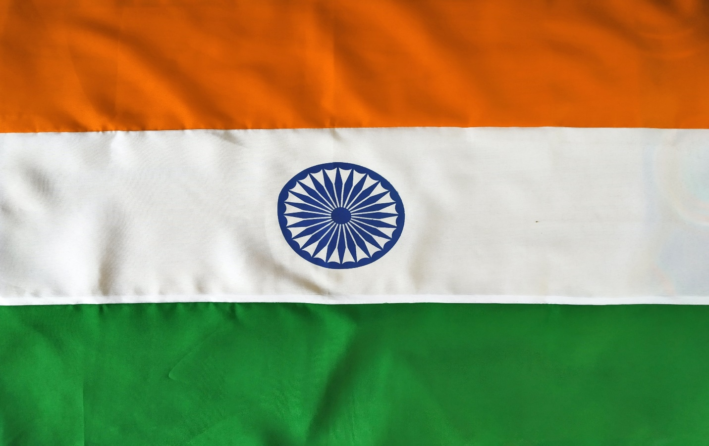[**http://24x7outsourcing.com/**](http://24x7outsourcing.com/)

**What Languages Are Spoken in India?**

What language is spoken in India? That is a greater inquiry than it shows up! India is home to extraordinary phonetic variety.

As an interpretation organization working with customers across the Indian Subcontinent, 24x7offshoring.com is all around used to changing one Asian language over to another.

**What are the dialects in India?**

**Bodo**

Additionally called Boro, Bodo is a Sino-Tibetan language spoken primarily in Northeast India, Nepal and Bengal, just as in Assam and the Bodoland self-governing district.

The language has 1.4 million speakers and is composed utilizing the Devanagari content, which it has utilized since 1963. Before that, it utilized Latin and Assamese content, however a few researchers accept that it recently had its own content – Deodhai – which has been lost to the ways of the world.

**Dogri**

With almost 2.6 million local speakers, Dogri is spoken fundamentally in the Jammu area of Jammu and Kashmir, just as in northern Punjab and in Himachal Pradesh. A few assortments of it are spoken.

**Gujarati**

The Indian territory of Gujarat is home to the Gujarati language, which has nearly 55 million local speakers. An Indo-European language, it isn't just an authority language in Gujarat, yet in addition in Dadra and Nagar Haveli and Daman and Diu.

**Hindi**

Hindi isn't just the principle language in India, it's additionally the fourth most generally utilized local language in the world.

24x7offshoring.com consistently gives Hindi interpretation administrations to customers both inside India and in nations hoping to work with those in India. Our Hindi restriction administrations are likewise searched out by those hoping to exchange beneficially with India.

**Kashmiri**

The Kashmiri language has around 6.7 million speakers, a large portion of whom dwell in the Jammu and Kashmir region, where it is perceived as an authority territorial language. In the Kashmir Valley space of the area, Kashmiri has been an obligatory language to learn in schools up to auxiliary level since 2008.

**Konkani**

Konkani is a language expressed along India's western coast. It has around 2.2 million local speakers and is the authority language of the province of Goa, just as being a minority language in different regions (counting Karnataka, Maharashtra, Kerala, Gujarat and Dadra and Nagar Haveli and Daman and Diu).

Notwithstanding standard Konkani, the language has various vernaculars, some of which are just incompletely commonly understandable.

**Maithili**

The Indo-Aryan Maithili language has around 13.5 million speakers in India, for the most part situated in the Bihar and Jharkhand states. Maithili is likewise the second most communicated in language in Nepal.

**Malayalam**

Generally spoken in Kerala, just as in Lakshadweep and Puducherry, Malayalam is spoken by around 2.8% of the absolute Indian populace, which likens to some 34.8 million speakers.

It is additionally broadly utilized in Gulf nations, because of critical quantities of Malayali expats taking the language with them.

**Manipuri**

Manipuri, otherwise called Meitei, is an apparent Sino-Tibetan language spoken generally in Northeastern India, in the Assam and Tripura states.

It has over 1.7 million local speakers and has been perceived in the Constitution of India since 1992. UNESCO has grouped it as a weak language.

**Marathi**

An authority language of both Maharashtra and Goa in Western India, Marathi has nearly 83 million local speakers, making it the third most generally communicated in language in the country.

A language verbally expressed in India for above and beyond a thousand years, Marathi has the absolute most established artistic works of all Indian dialects still being used today.

**LANGUAGES IN INDIA**

**https://24x7offshoring.com/**

**http://24x7outsourcing.com/**